Name : Saurabh Sanjay Jadhav

Topic : Jenkins webhook trigger and parameterized job.

Assignment no : 22

1. Add the URL in the webhook of github.

Copy URL from manage Jenkins/system under github settings

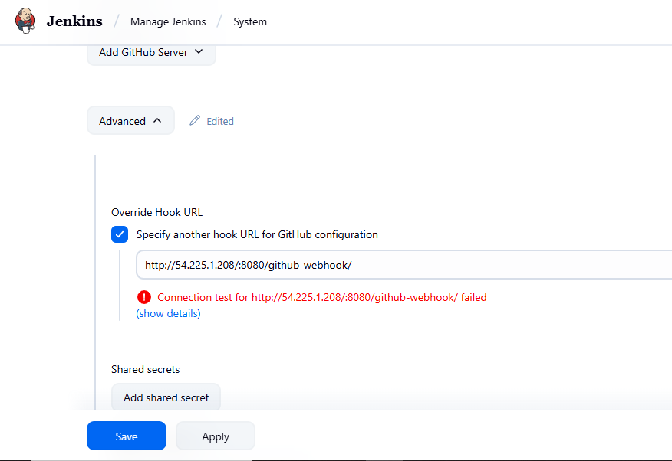

Paste it to webhook details of github.

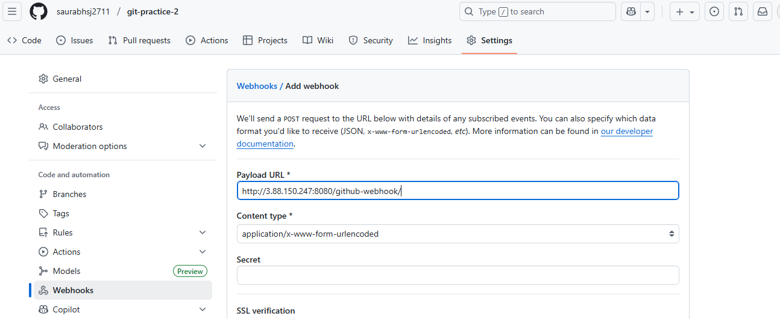

1. Create new job for webhook trigger.

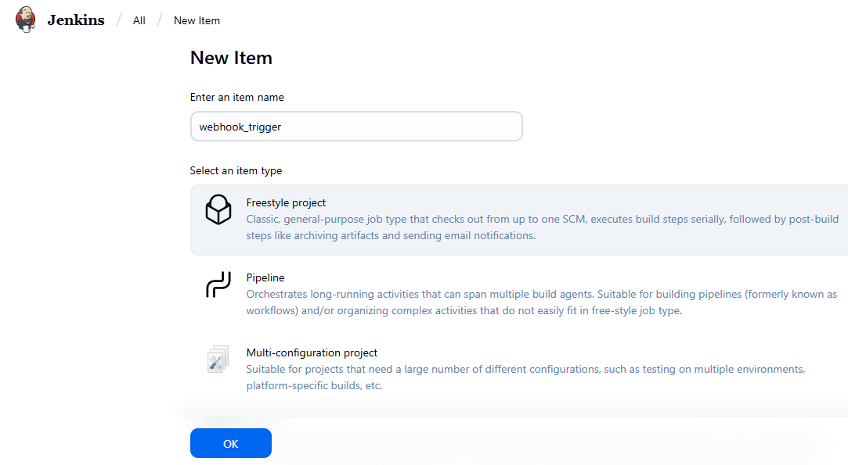

Provide the git link

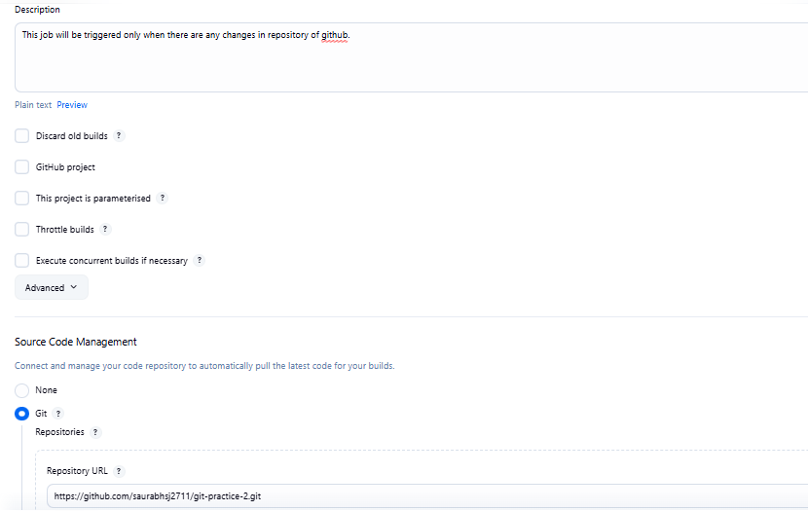

Add the trigger for github hook

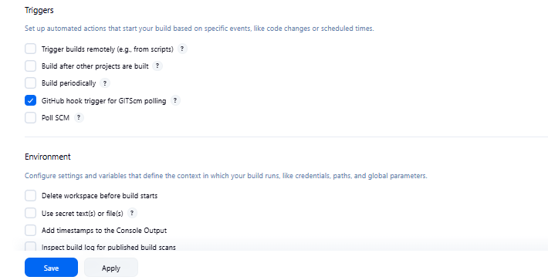

Hence job created successfully

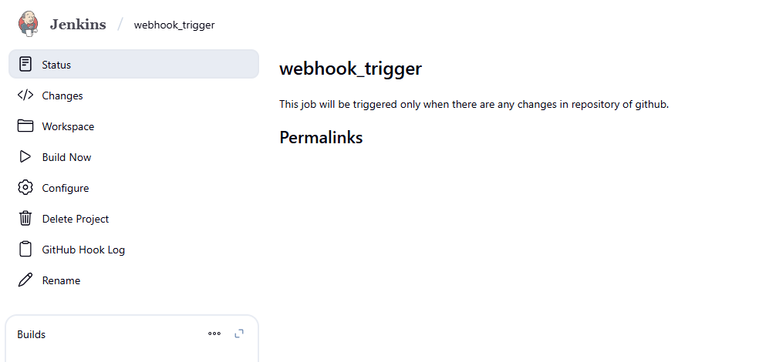

1. Build the job
2. 1st build to start the job

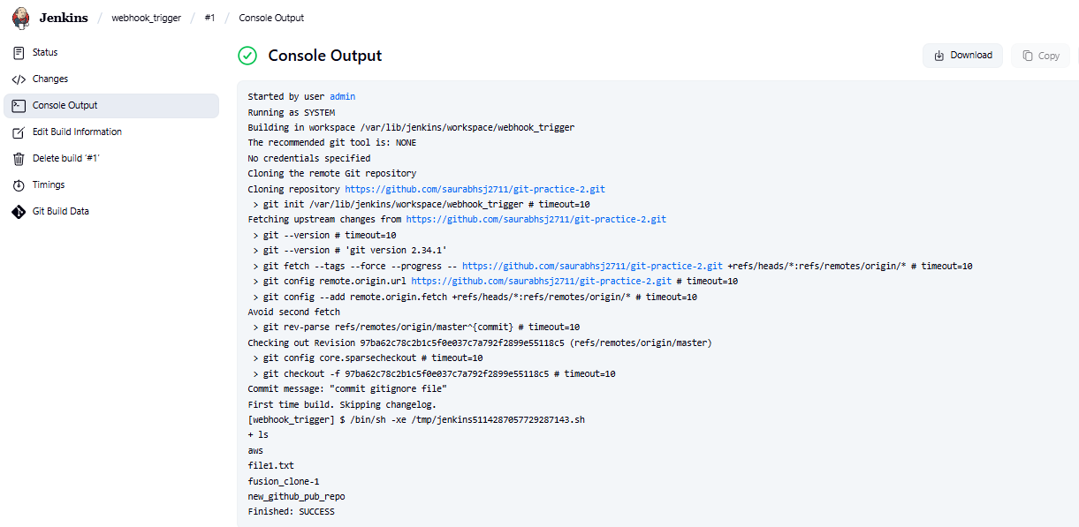

1. 2nd build

Created the new file in repository.

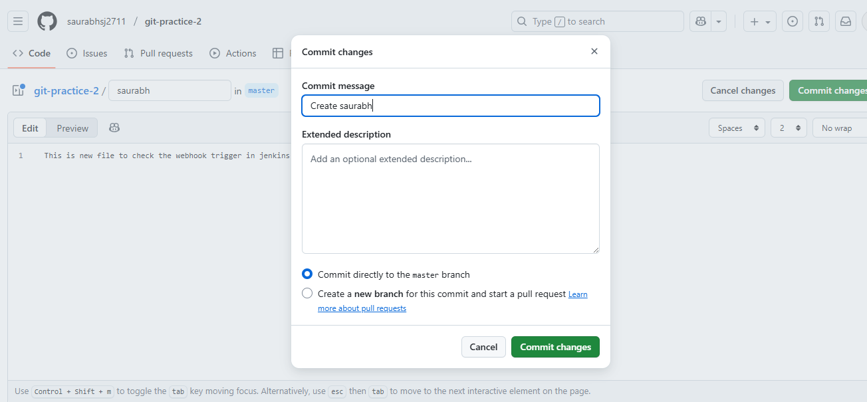

As soon as file is created in repository the webhook triggered the 2nd build

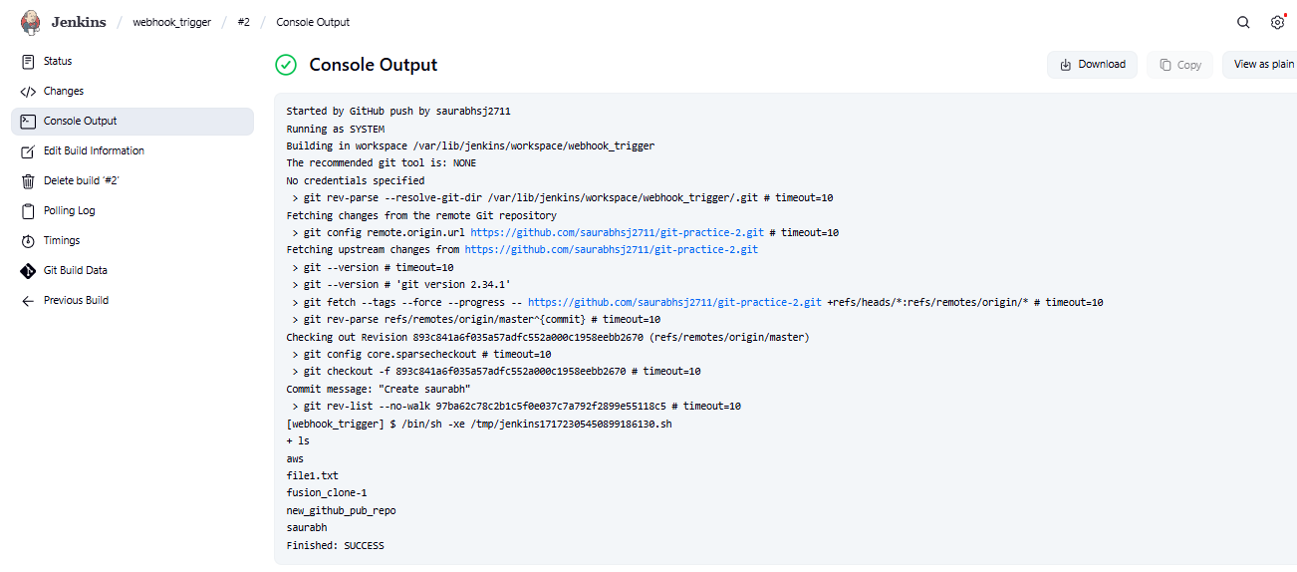

1. Creating parameterized jobs
2. Boolean parameter

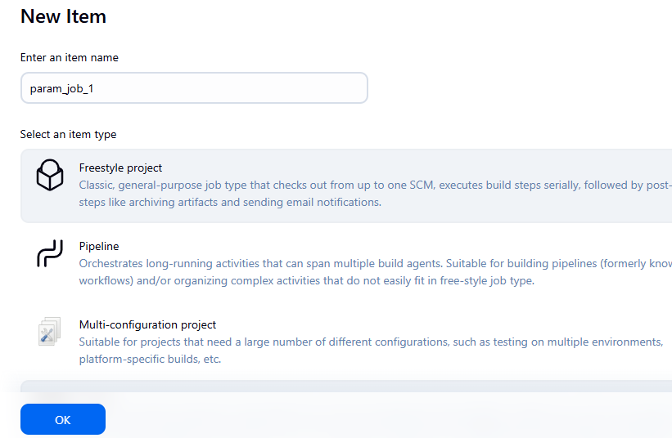

Created the job with Boolean parameter

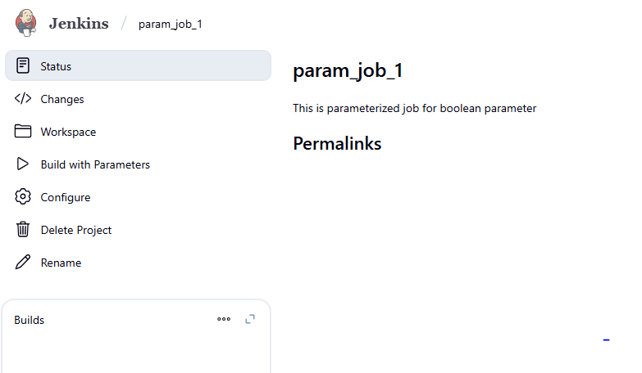

Check the parameter

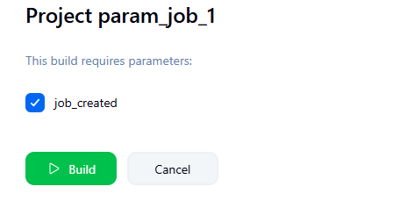

Successfully build the job

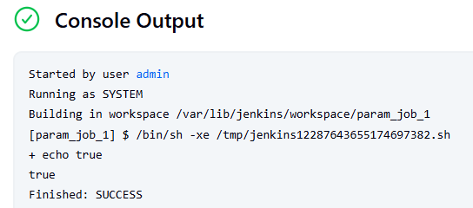

1. Choice parameter

Creating choice parameter

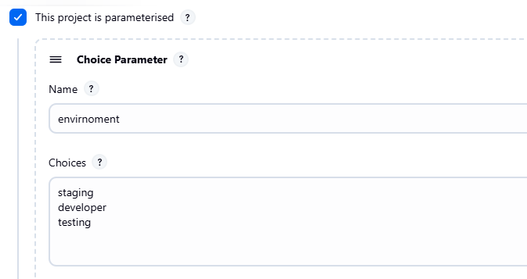

Created the job and build using the choice parameter.

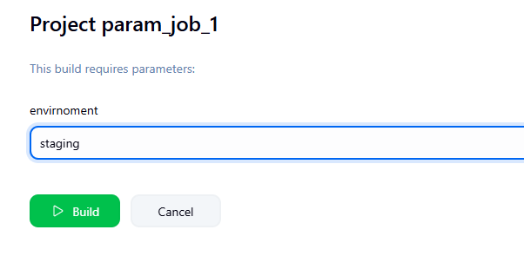

Successfully build the job with choice parameter

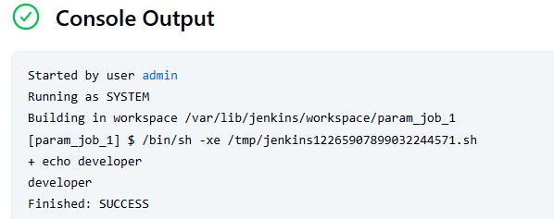

1. Password parameter.

Creating job with password parameter.

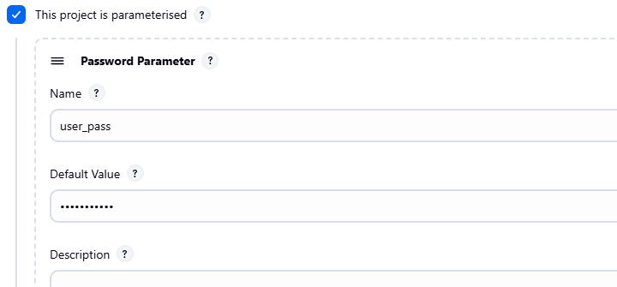

Successfully build the job

